 

**Assignment #01**

**Computer Networks Lab**

**Submitted To:**

**Instructor: Mr. Adnan Shah**

**Name: Abdul Saboor**

**Reg ID: 200997**

**Class: BS-CYS-F20-A**

**Task 1:**

|  |  |  |  |  |  |
| --- | --- | --- | --- | --- | --- |
| **Sr.No** | **IP Address** | **Class** | **Usage** | **Type** | **Status** |
| **1.** | 247.197.147.97 | E | Public | Invalid | Reserved |
| **2.** | 244.194.144.94 | E | Public | Invalid | Reserved |
| **3.** | 241.191.141.91 | E | Public | Invalid | Reserved |
| **4.** | 238.188.138.88 | D | Public | Invalid | Reserved |
| **5.** | 235.185.135.85 | D | Public | Invalid | Reserved |

**Task 2:**

1. **Pinging the 1st IP:**



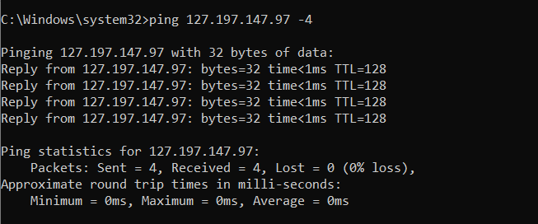

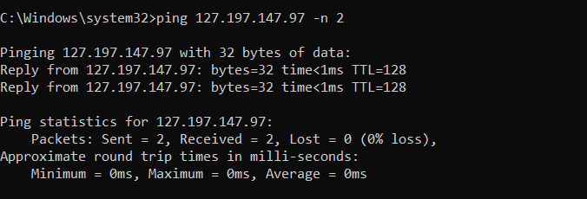

1. **Pinging the 2nd IP:**

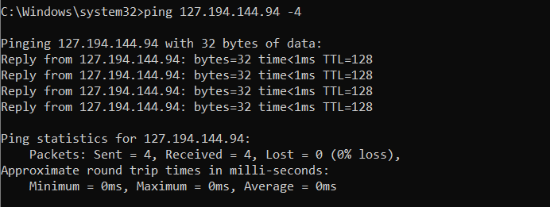

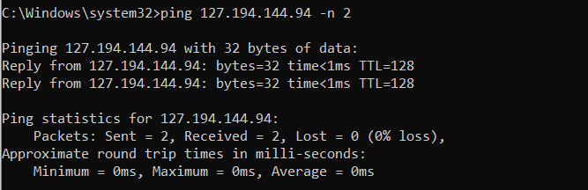

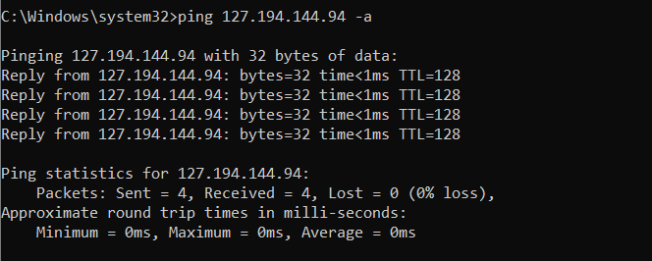

1. **Pinging the 3rd IP:**

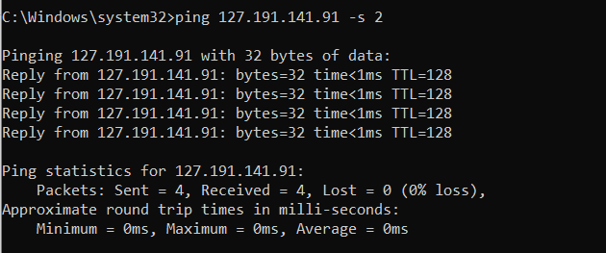

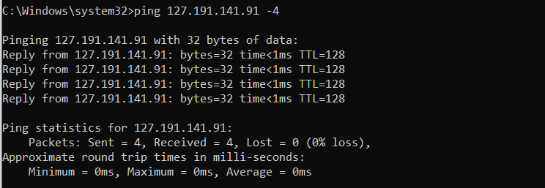

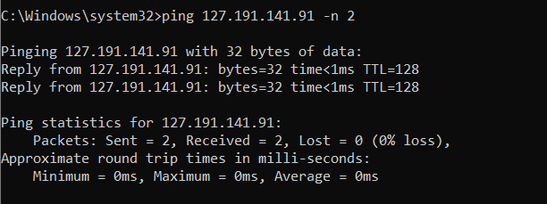

1. **Pinging the 4th IP:**



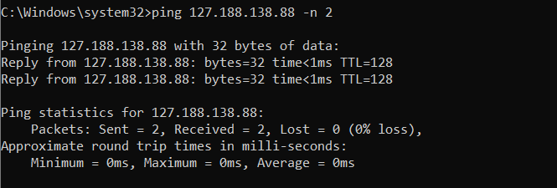

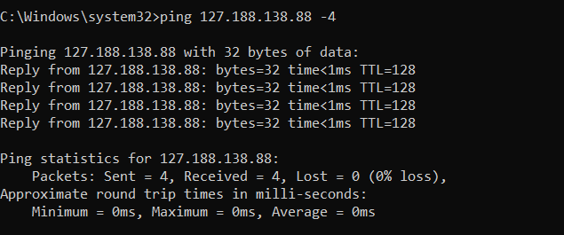

1. **Pinging the 5th IP:**

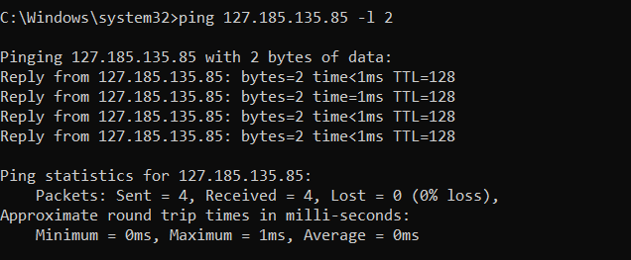

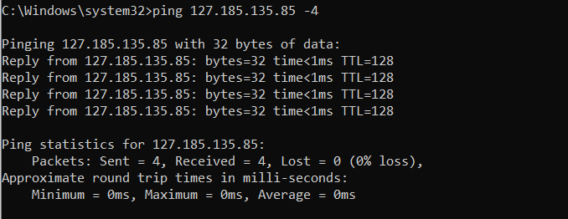



**Task 3:**

1. **Google.com:**

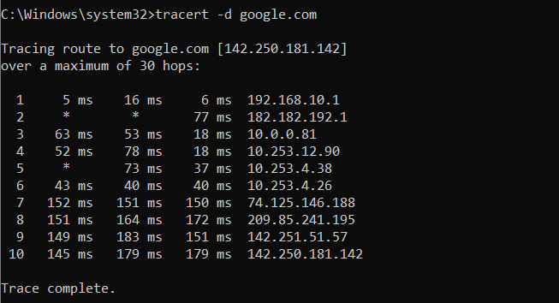

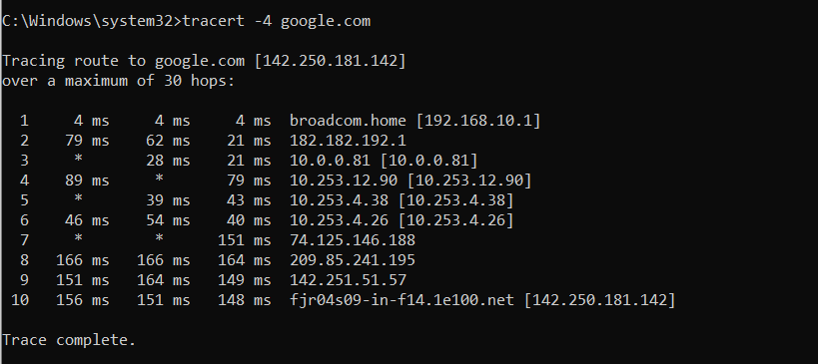

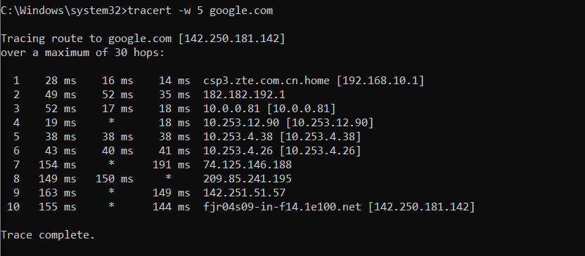

1. **Yahoo.com:**

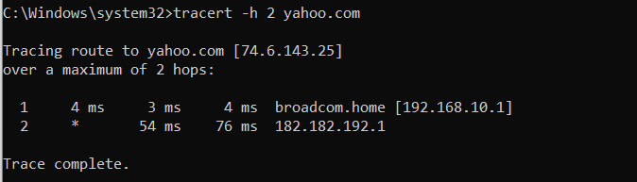

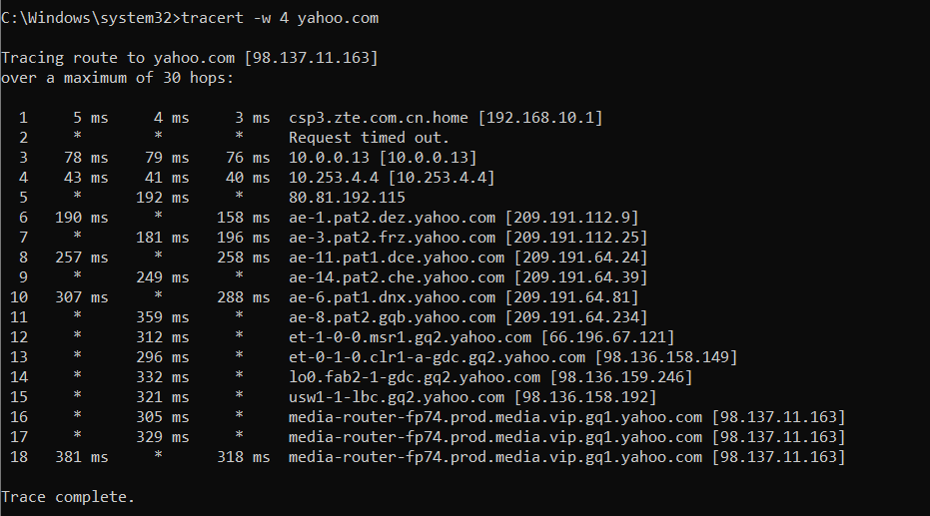

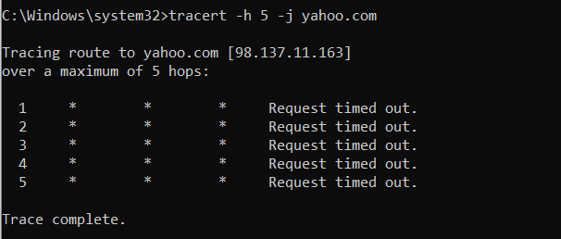

1. **Facebook.com:**

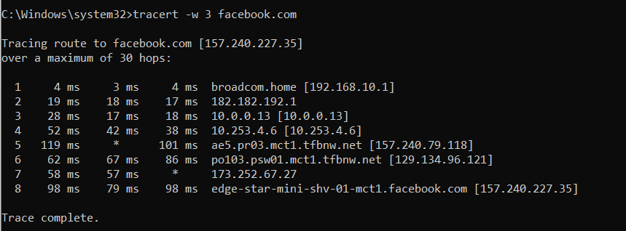

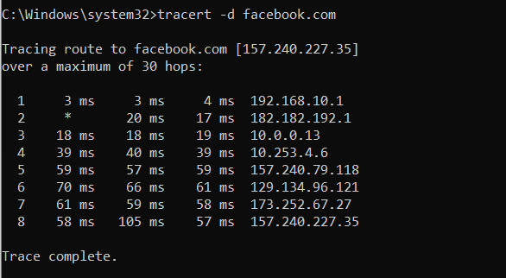

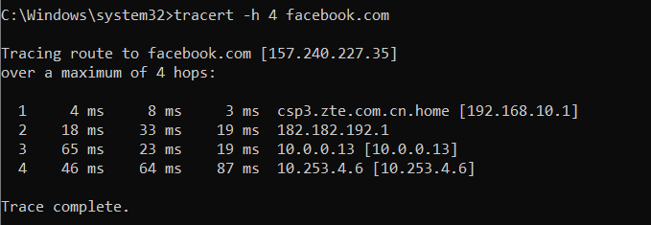

1. **Instagram.com:**

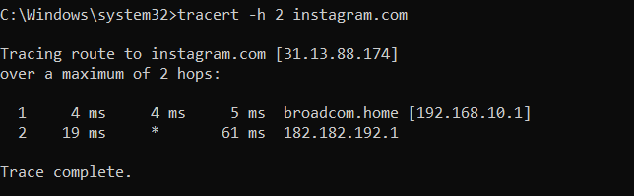

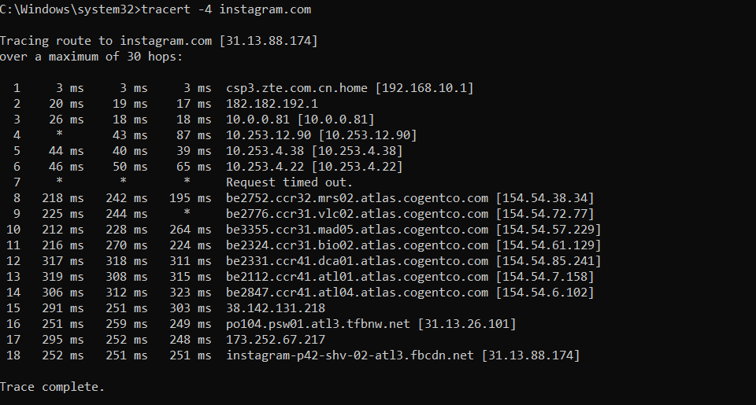

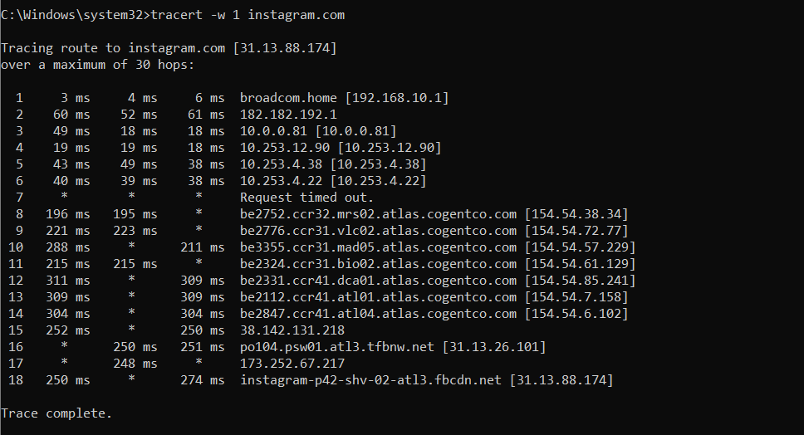

1. **Whatsapp.com:**

